Problem 1 Testing

1. Test Objective
To verify the correctness of the Morris Inorder Traversal implementation. This test ensures that:
- The Morris algorithm produces the correct Inorder sequence compared to a standard recursive DFS.
- The algorithm correctly identifies predecessors and threads the tree.
- Crucially: The algorithm restores the binary tree to its original structure after traversal (no permanent modification of pointers).

Test 1: Baseline & Traversal Output
Description: Run the application. The system should print the "Before" state (standard recursive) and the "Morris" traversal result.
- Expected Result:
  - Recursive Inorder: [4, 2, 5, 1, 3, 6]
  - Morris Inorder: [4, 2, 5, 1, 3, 6]
Evidence:
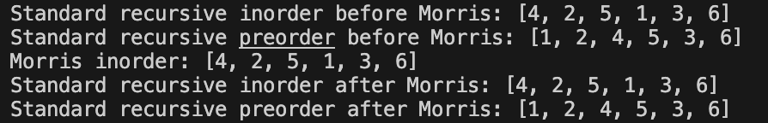

Test 2: Structure Restoration Output
Description: After the Morris traversal completes, the system runs the standard traversals again to ensure the tree pointers were reset (the predecessor.Right = null step in the code).
- Expected Result:
  - Recursive Inorder (After): [4, 2, 5, 1, 3, 6]
  - Recursive Preorder (After): [1, 2, 4, 5, 3, 6] (Must match the "Before" Preorder).
Evidence: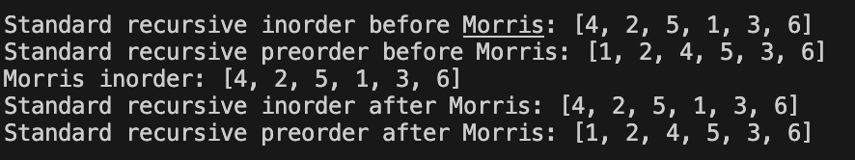

Test 3: Automated Verification Logic
Description: The Main method runs boolean checks (SeqEqual) to programmatically confirm data integrity.
- Expected Result: All three checks must read PASS.
  - Morris produced same inorder: PASS
  - Tree structure reinstated: PASS
  - Inorder before equals inorder after: PASS
Evidence: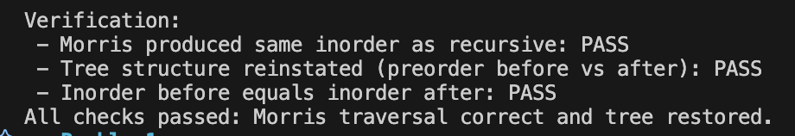

4. Conclusion
Overall Status: [ PASS ]

